**SKILL AND JOB RECOMMENDER**

PREPARE EMPATHY MAP

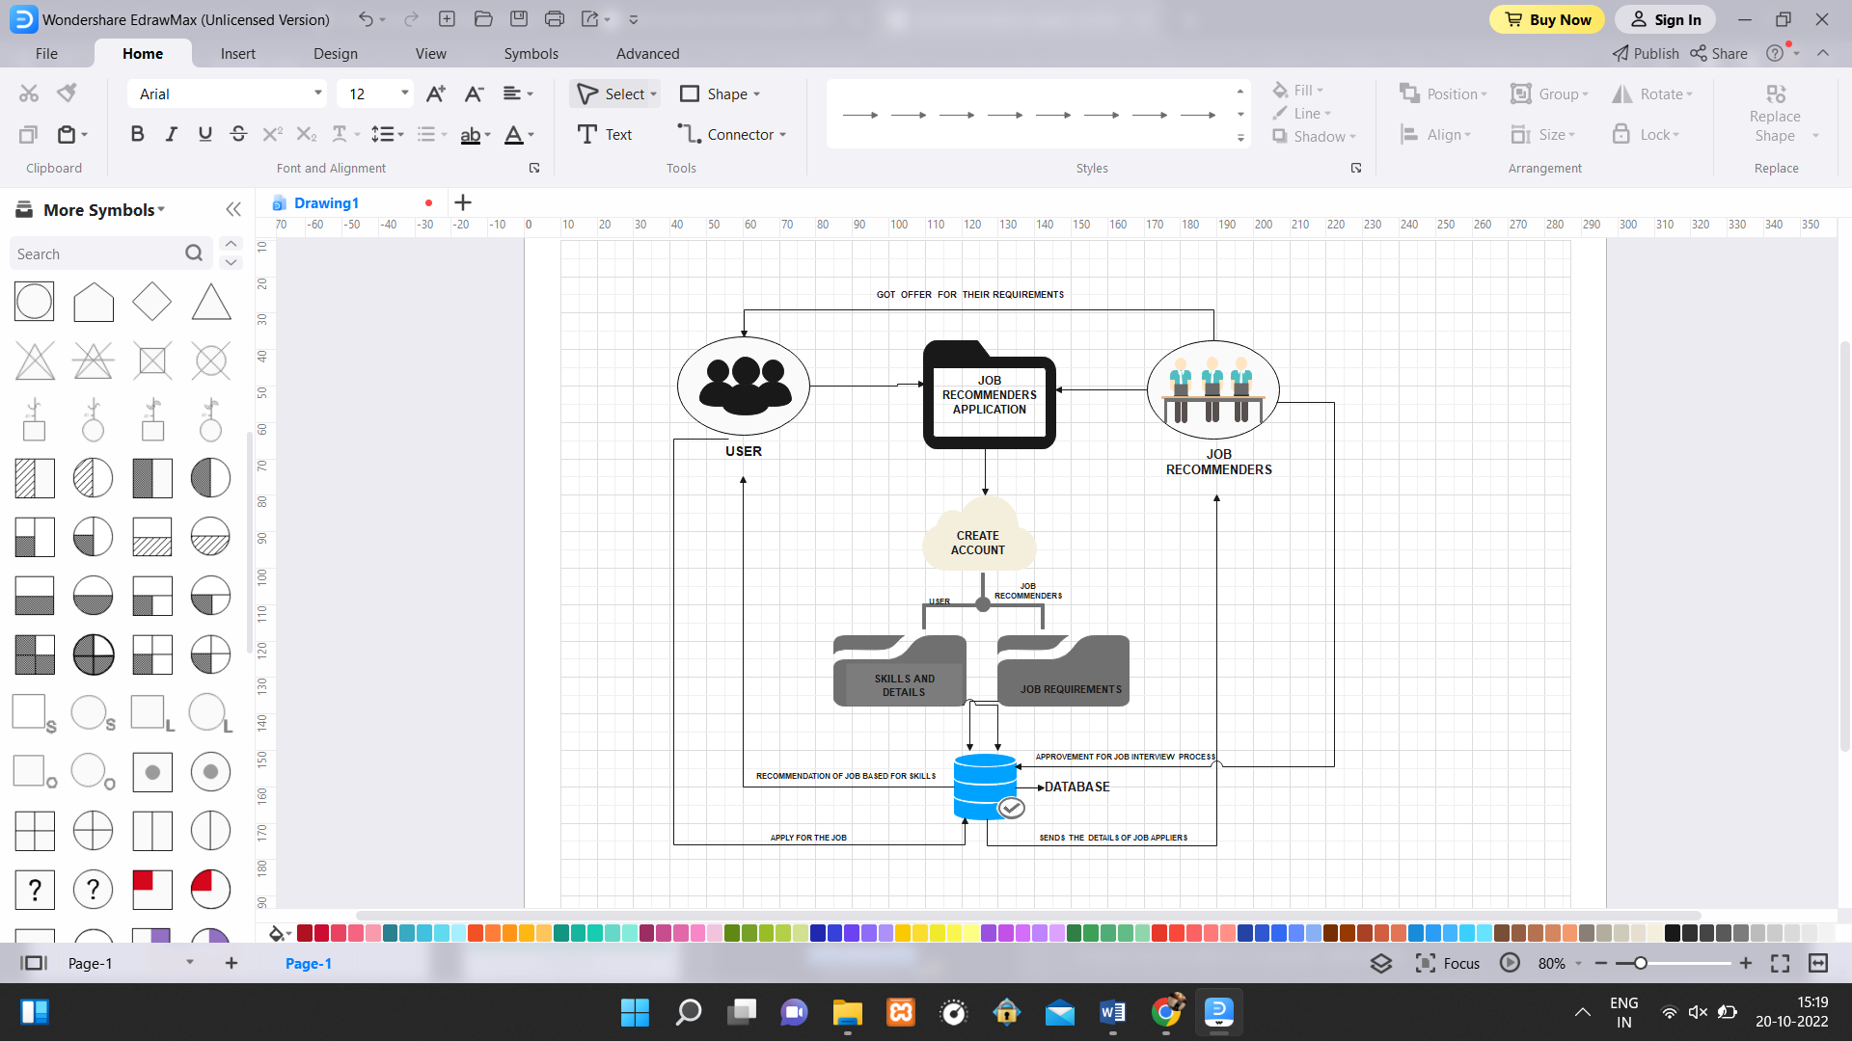

WORKING ARCHITECTURE

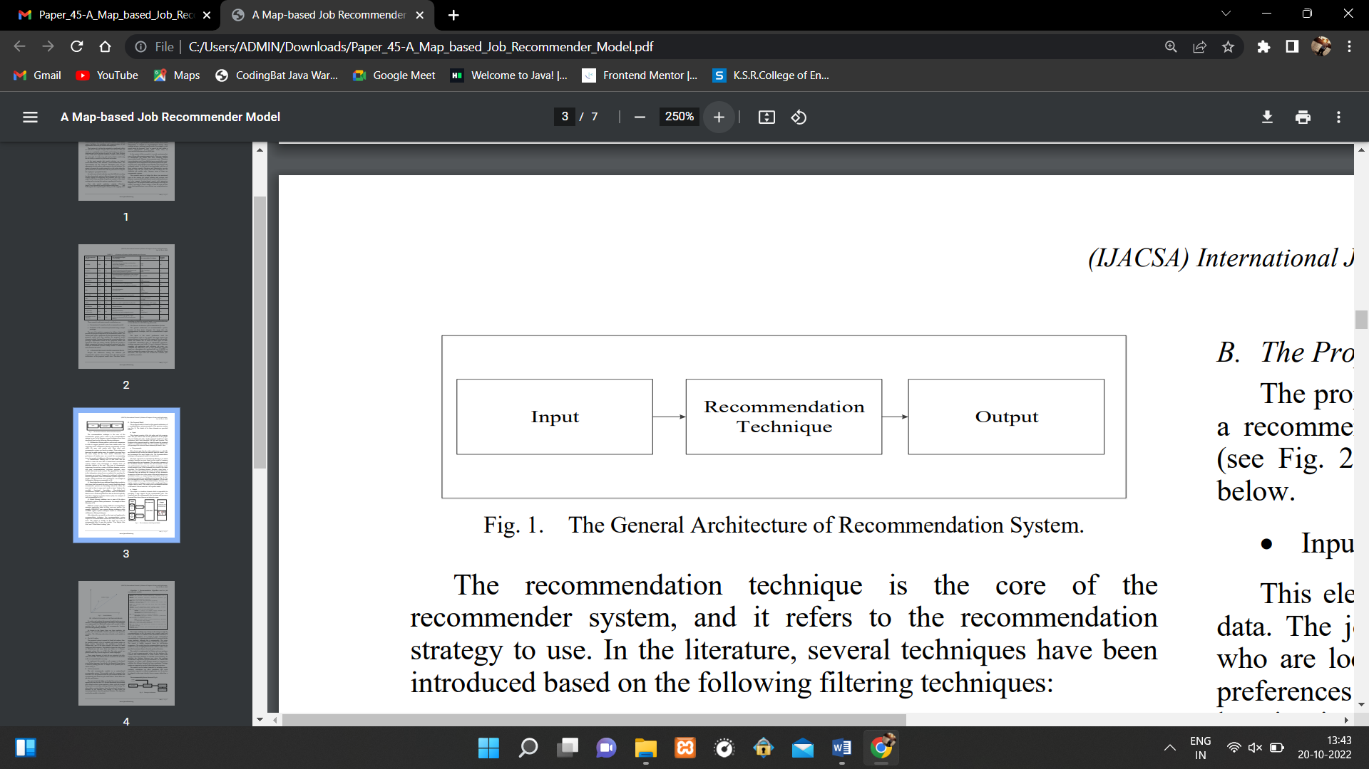

GENERAL ARCHITECTURE OF RECOMMENDER SYSTEM

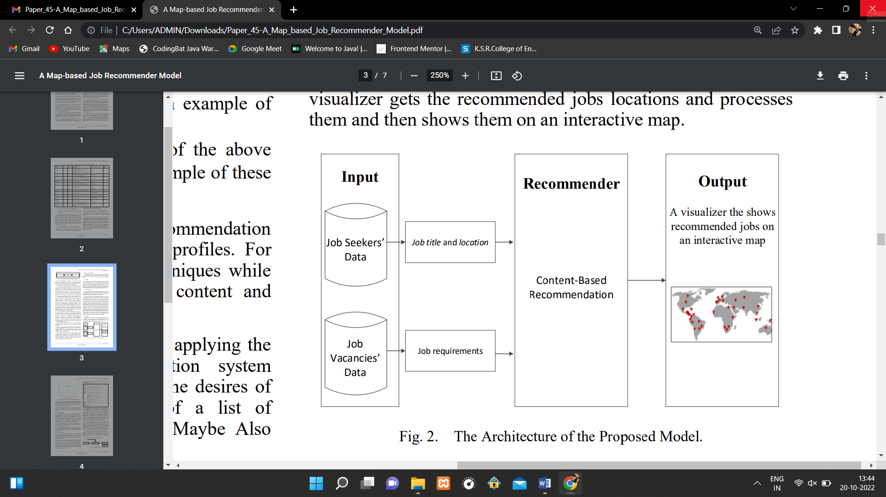

ARCHITECTURE PROPOSED SYSTEM

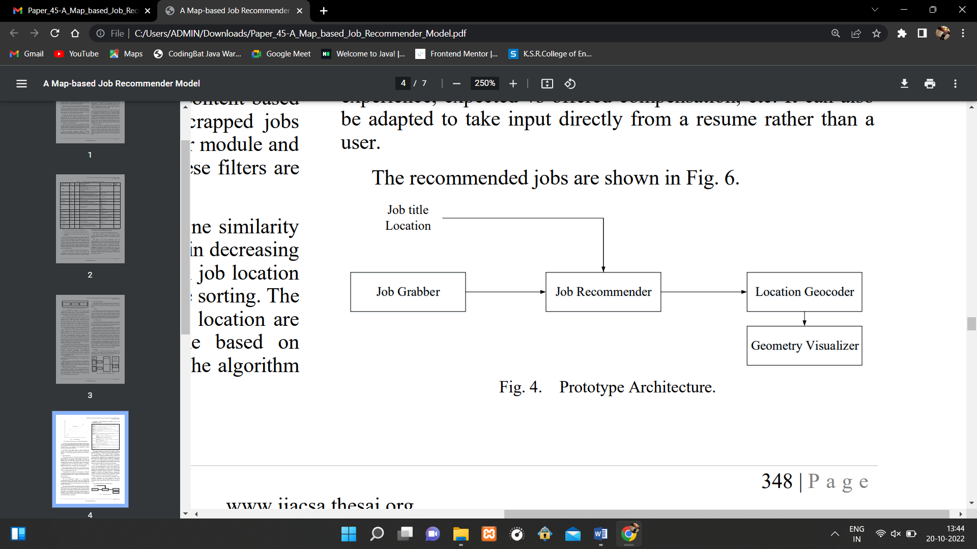

PROTOTYPE ARCHITECTURE